
FIRE FIGHTING EQUIPMENT PROVISIONS
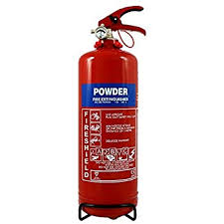
WHEN CUTTING RAIL, DECANTING OR TRANSPORTING FUEL, FIRE FIGHTING EQUIPMENT (SUCH AS 2kg POWDER FIRE EXTINGUISHERS) AND/OR SPILL KITS MUST BE ON SITE.
Fire precautions, including provision of fire-fighting equipment on site Fire / Explosion - All Staff / COSS / Team Leader (NR/L3/MTC/RCS0216/TK64)
Re-fuelling– Fire / Explosion - One 2kg Dry Powder fire extinguisher shall be available when fuelling Disc Cutters - All Staff / COSS / Team Leader (NR/L3/MTC/RCS0216 /SP10)
Dry Powder Fire Extinguishers can be found on Office Depot (Product Code 548766)


