
FIRST AID KITS CAN ONLY BE USED IF YOU HAVE THEM WITH YOU!
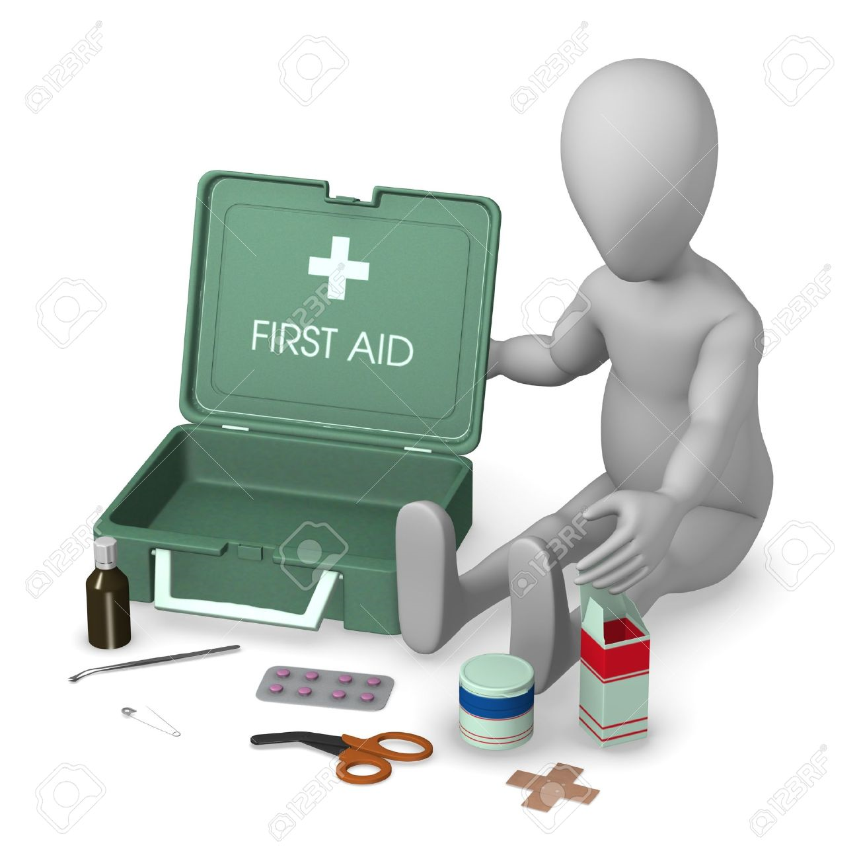
The First Aid at Work Standard (NR/L2/OHS/00110) states that;
The Person in Charge should confirm whether:

a) there is sufficient first aid cover for the work activities to be undertaken;

b) the first aid kit is readily available on scene and appropriately stocked for the work activity;

c) prior to starting any works all workers in the group are aware of the first aid
arrangements; and

d) first aiders can be easily identified in the event of an emergency.
PLEASE, TAKE THE FIRST AID KIT OUT WITH YOU, YOU NEVER KNOW WHEN YOU MAY NEED IT!
The First Aid Kit (Essential 10 People) is available on Office Depot (product code 4255890), as is the First Aid Kit for Burns (product code 4991208)

