IMDM INNER
Title: Welding and Grinding Manual Handling Accident
Injury: Back Strain.

Incident
On Sunday the 28th of October 2018, 2 members of Network Rail staff from the Wimbledon Welding and Grinding (W&G) department were assisting the maintenance team in the installation and stressing of a 30-foot rail at Ewell West, on the RPE (Raynes Park - Epsom) line.

As part of the activity, the W&G team had to blank weld one section of rail prior to the rail being stressed and before the second end of the new rail was thermit welded to the existing track.

This happened without incident and left the rail grinding of the welds to be completed. The Welding and Grinding team retrieved the MP12 hand held rail grinder from the platform.

The W&G team chose to manually handle the MP12 down from the platform to the track, despite their being a sloped access to the track at the end of the platform, approximately 100 yards away.

As the grinder (weighing 68KG approx.) was being passed down from the platform to the track, one of the team experienced a sharp pain in his back. The pain was fleeting, and the Welder did not feel any more discomfort throughout the night or throughout Sunday. Due to this, the Welder did not report the accident at the time or report it to his Line Manager once he'd returned to his depot.

The Welder noticed some pain and discomfort later and notified his manager of the accident 2 days after the event.

The Welder was signed off duties until the 20th of November.

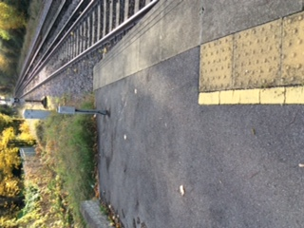

Learning lessons;
The reporting of accidents, no matter how insignificant you believe them to be, must take place. It is for your benefit.

Additionally:
- THINK; Can the lift be avoided?
- Where alternative methods of accessing the track are available, consider using them.
- Assess the weight of the equipment. Do you have the resources or capability to safely carry out the lift?
- Avoid twisting and keep the load close to your body.
- Know your limits!

