Hand Sanitiser with 70% alcohol content is classed as a Category 2 Flammable Liquid and strict storage and control arrangements must be adhered to.

- A DSEAR assessment must be undertaken for the storage of any flammable liquid by the PRFS supported by the Fire Safety Team. This must be shared and briefed to all relevant staff.

- The PRFS must read the following guidance and share with all relevant parties;
- HSE Guidance on Storage of Flammable Liquids in Containers https://www.hse.gov.uk/PuBns/priced/hsg51.pdf
- HSE Guidance on Safe Use and Handling of Flammable Liquids https://www.hse.gov.uk/pubns/priced/hsg140.pdf
- HSE Guidance on Dangerous Substances and Explosive Atmospheres https://www.hse.gov.uk/pubns/priced/l138.pdf

- Containers must be stored external to any occupied building in an unenclosed area. This ideally should be external to the premises however; internal roadways and compounds can be considered. Where this is not possible further guidance is given below.

- Where unenclosed storage is not possible the following must be adhered to;
  - Prior approval from the Fire Safety Engineer is required.
  - Storage must be within 30min fire resisting enclosure.
  - Storage rooms must be dedicated for the storage of flammable liquid and no other material.
  - Storage rooms must be bunded or the use of the cabinets below can be utilised.
  - Storage rooms must not be used for anything other than storage including decanting of flammable liquid.
  - Ventilation calculations must be completed to demonstrate that room has adequate ventilation (either natural or mechanical)

- Unless being stored in a dedicated storage room with the above control measures, containers must be stored in a fire resisting cabinets such as the one below, these cabinets must not be used for the storage of any other dangerous or other substance.
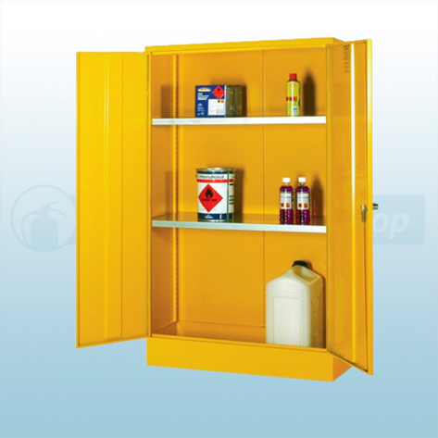
  - Cabinets must be bonded / grounded to prevent ignition sources from static.
  - Cabinets must have adequate bunding / sump to catch any spillages arising from 1 full container.
  - Cabinets must not be overfilled, and storage must not inhibit the ventilation.

- There must be emergency procedures in place for spillages and staff must be trained on these.

- A 9 Litre AR-AFFF fire extinguisher should be in situ near storage area. Must be alcohol resisting foam.

- A maximum of 1000L of flammable liquid is permitted at any one site.

- No combustible material should be stored within 2m of external storage, all packing material must be removed.

- No HV or LV cables within 3m of external storage areas

- Due to vapours being heavier than air, no storage is permitted in basement or underground areas or within 2m of any open drain, gulley or catch pit / inspection covers.

- Consideration must be made where larger containers are to be decanted into smaller containers (ie dispensers). This cannot be completed in the same location as internal storage and must have adequate measures for preventing spillages and collecting drips. Ventilation must be sufficient to prevent a build-up of flammable vapour (min 10 air changes an hour). A Work Activity Risk Assessment and Safe System of Work should be documented and briefed to all relevant staff.

- No storage of flammable liquid is permitted in any volume other than areas identified within the DSEAR.
- Signage must be installed as per below on both the entrance to the storage area and on the storage cabinet.
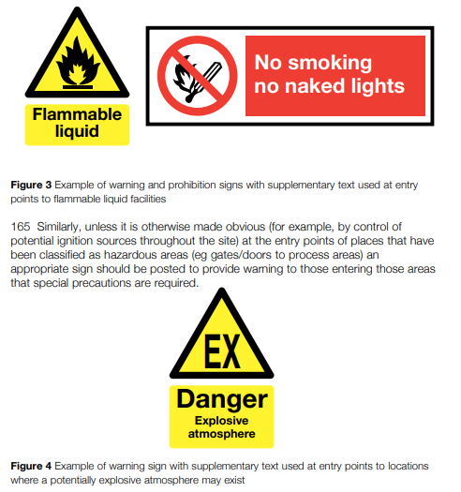

MATERIAL SAFETY DATA SHEET — 16 Sections
SECTION 1 — CHEMICAL PRODUCT AND COMPANY IDENTIFICATION
Product Identifier  Hand Sanitiser |  |  |  | [WHMIS Classification]  Flammable Liquids – Cat 2
Product Use
External use only – apply small amount to area to be sanitised and rub together.
Manufacturer’s Name  Summerhall Distillery Ltd |  |  | Supplier’s Name
Street Address  1 Summerhall |  |  | Street Address
City  Edinburgh |  | Province  City of Edinburgh | City |  |  | Province
Postal Code  EH9 1PL | Emergency Telephone  0131 2902901 |  | Postal Code |  | Emergency Telephone
Date MSDS Prepared  01/04/2020 |  | MSDS Prepared By  D Quinnell |  | Phone Number  0131 2902901

SECTION 2 — COMPOSITION/INFORMATION ON INGREDIENTS
Hazardous Ingredients (specific) | % by weight | CAS Number
Ethanol | 70 | 64-17-5
Hydrogen Peroxide | 4.17 | 7722-84-1
Glycerol | 1.45 | 56-81-5

SECTION 3 — HAZARDS IDENTIFICATION

Keep away from heat/sparks/open flames/hot surfaces. — No smoking
Keep container tightly closed
Ground/bond container and receiving equipment
Use explosion-proof equipment
Use only non-sparking tools
Take precautionary measures against static discharge
Wear protective gloves/protective clothing/eye protection/face protection

SECTION 4 — FIRST AID MEASURES

Skin Contact
If skin irritation occurs, rinse affected area with water
Eye Contact
Rinse immediately with plenty of water, also under the eyelids, for at least 15 minutes.
Inhalation
Remove to fresh air
Ingestion
Dilute by giving a large amount of water. Call a physician or Poison Control Center.
SECTION 5 — FIRE FIGHTING MEASURES

Flammable  ❐Yes | If yes, under which conditions?  All
Means of Extinction
Carbon dioxide (CO2). Alcohol resistant foam. Dry chemical.
Flashpoint (° C) and Method  21 | Upper Flammable Limit (% by volume)  Not established | Lower Flammable Limit (% by volume)  Not established
Autoignition Temperature (°C)  365 °C | Explosion Data — Sensitivity to Impact  Not established | Explosion Data — Sensitivity to Static Discharge  Not established
Hazardous Combustion Products
Ethanol

SECTION 6 — ACCIDENTAL RELEASE MEASURES
Personal precautions, protective equipment and emergency procedures

Personal Precautions Use personal protective equipment as required.
Environmental Precautions See Section 12 for additional Ecological Information.

Methods and material for containment and cleaning up

Methods for Containment Prevent further leakage or spillage if safe to do so

SECTION 7 — HANDLING AND STORAGE
Precautions for safe handling
Advice on Safe Handling Keep away from heat/sparks/open flames/hot surfaces. — No smoking. Use spark-proof tools and explosion-proof equipment. Ground/bond container and receiving equipment. Take precautionary measures against static discharges.

Conditions for safe storage, including any incompatibilities
Storage Conditions Keep containers tightly closed in a dry, cool and well-ventilated place. Do not contaminate food or feed stuffs. Do not reuse container. Keep out of the reach of children.
Incompatible Materials Strong oxidizers. Hydrogen peroxide. Bromine. Chromic acid.

SECTION 8 — EXPOSURE CONTROL / PERSONAL PROTECTION

Exposure Guidelines

Chemical Name ACGIH TLV OSHA PEL NIOSH IDLH
Ethanol 64-17-5 STEL: 1000 ppm TWA: 1000 ppm IDLH: 3300 ppm
TWA: 1900 mg/m3 TWA: 1000 ppm
(vacated) TWA: 1000 ppm TWA: 1900 mg/m3
(vacated) TWA: 1900 mg/m3

Chemical Name ACGIH TLV OSHA PEL
Glycerol 56-81-5 TWA: 10 mg/m3 mist TWA: 15 mg/m3 mist, total particulate
TWA: 5 mg/m3 mist, respirable fraction
(vacated) TWA: 10 mg/m3 mist, total particulate
(vacated) TWA: 5 mg/m3 mist, respirable fraction

Appropriate engineering controls
Engineering Controls Apply technical measures to comply with the occupational exposure limits. Ventilation systems.

Individual protection measures, such as personal protective equipment

Eye/Face Protection Avoid contact with eyes.
Skin and Body Protection No special technical protective measures are necessary.
Respiratory Protection No protective equipment is needed under normal use conditions.
General Hygiene Considerations Do not get in eyes. Keep away from food and drink.

SECTION 9 — PHYSICAL AND CHEMICAL PROPERTIES
Information on basic physical and chemical properties

Physical State Gel
Appearance Clear colourless liquid
Odor Alcohol
Color Clear
Odor Threshold Not determined

Property Values Remarks • Method
pH 6.00-8.00
Melting Point/Freezing Point Not established
Boiling Point/Boiling Range 100 °C / 212 °F
Flash Point 21 °C / 70 °F SETA
Evaporation Rate Not established
Flammability (Solid, Gas) Not determined
Upper Flammability Limits Not determined
Lower Flammability Limit Not determined
Vapor Pressure Not established
Vapor Density Not established
Specific Gravity .858 - .882
Water Solubility Completely soluble
Solubility in other solvents Not determined
Partition Coefficient Not determined
Autoignition Temperature Not determined
Decomposition Temperature Not determined
Explosive Properties Not determined
Oxidizing Properties Not determined

SECTION 10 — STABILITY AND REACTIVITY

Reactivity Not reactive under normal conditions.
Chemical Stability Stable under recommended storage conditions.
Possibility of Hazardous Reactions None under normal processing.
Hazardous Polymerization Hazardous polymerization does not occur.
Conditions to Avoid Keep out of reach of children.
Incompatible Materials Strong oxidizers. Hydrogen peroxide. Bromine. Chromic acid.
Hazardous Decomposition Products Carbon oxides.

SECTION 11 — TOXICOLOGICAL INFORMATION
Information on likely routes of exposure
Product Information
Eye Contact Avoid contact with eyes.
Skin Contact Not expected to be a skin irritant during prescribed use.
Inhalation Avoid breathing vapors or mists.
Ingestion Do not taste or swallow

SECTION 12 — ECOLOGICAL INFORMATION
Ecotoxicity Toxic to aquatic life with long lasting effects.
Persistence/Degradability Not determined
Bioaccumulation Not determined
Mobility
Chemical Name Partition Coefficient
Ethanol 64-17-5 -0.32
Other Adverse Effects Not determined

SECTION 13 — DISPOSAL CONSIDERATIONS
Waste Treatment Methods

Disposal of Wastes Disposal should be in accordance with applicable regional, national and local laws and regulations. Contaminated Packaging Disposal should be in accordance with applicable regional, national and local laws and regulations.

SECTION 14 — TRANSPORT INFORMATION
Note: 100ml and 10,000ml containers, is shipped as Limited Quantity

DOT
UN/ID No UN1170
Proper Shipping Name Ethanol solution
Hazard Class 3
Packing Group II

IATA
UN/ID No UN1170
Proper Shipping Name Ethanol solution
Hazard Class 3
Packing Group II

IMDG
UN/ID No UN1170
Proper Shipping Name Ethanol solution
Hazard Class 3
Packing Group II

SECTION 15 — OTHER INFORMATION
Issue Date 08-APR-2020 Revision Date: 01-APR-2022
Revision Note First Issue

DISCLAIMER: This information relates onto to the specific material designated and may not be valid for such material used in combination with any other materials or in any process. The information and recommendations contained herein are to the best of the manufacturer’s knowledge and belief accurate and reliable as of the date indicated. No representation warranty or guarantee, however, is made with regards to accuracy, reliability or completeness. Conditions of use of the material are under the control of the user; therefore, it is the user’s responsibility to satisfy itself as to the suitability and completeness of such information for its own particular use. Appropriate warnings and safe-handling procedures should be provided to handlers and users.

