Why should we do face-fit-testing?
Several Regulations, COSHH (Control of Substances Hazardous to Health), Control of Asbestos at Work Regulations and the Control of Lead at Work Regulations require for all tight-fitting facepieces to be face-fit tested to ensure the wearer has a correctly fitting device.
The performance of tight-fitting facepieces depends on achieving a good contact between the wearer’s skin and the face seal of the facepiece.
If tight-fitting facepieces are not face-fit-tested to ensure good fit, then they significantly reduce the protection provided to the wearer. Whilst providing the illusion of protection.

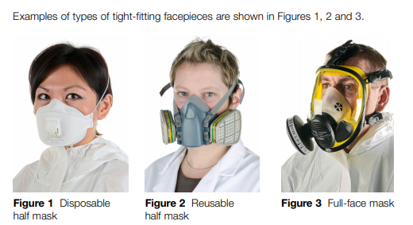

What is face-fit-testing?
Fit testing is a method for checking that a specific model and size of tight-fitting facepiece matches the wearer’s facial features and seals adequately to the wearer’s face. It will also help to identify unsuitable facepieces which should not be used.
There are two different types of face-fit-testing, however we will primarily be using Qualitative fit testing (QLFT). This is a pass/fail test based on the wearer’s subjective assessment of any leakage through the face seal region by detecting the introduction of bitter- or sweet-tasting aerosol as a test agent. QLFT methods are suitable for disposable and reusable half masks; they are not suitable for full-face masks.

When do we need to do face-fit-testing?
A fit test should be carried out as part of the initial selection of the RPE. A fit test should be repeated whenever there is a change to the RPE type, size, model or material or whenever there is a change to the circumstances of the wearer that could alter the fit of the RPE; for example:
- weight loss or gain;
- substantial dental work;
- any facial changes (scars, moles, effects of ageing etc) around the face seal area;
- facial piercings;
- introduction or change in other head-worn personal protective equipment (PPE).
- Or every three years as part of a normal repeat review process.

Who can do face-fit-testing?
The Law requires face-fit-testing should be conducted by a competent person. Competence can be demonstrated by accreditation under the Fit2Fit RPE Fit Test Providers Accreditation Scheme. This scheme has been developed by the British Safety Industry Federation (BSIF), together with industry stakeholders, and is supported by HSE.
The scheme is not compulsory and employers are free to take other action to comply with the law.

What is fit-checking?
The wearer performs a pre-use seal check each time a tightfitting facepiece is worn and before entering the hazardous environment. This check is to determine whether the wearer has correctly donned a facepiece before entering a contaminated work area. The RPE manufacturer will provide instructions on how to carry it out. A pre-use wearer-seal check (fit check) is not a substitute for fit testing.

How will face-fit-testing be managed in Wessex Route?
Existing employees:
Each SM will need to arrange face-fit-testing sessions for their employees that are issued tight fitting facemasks as part of their normal PPE to undertake certain work activities linked to their job role.

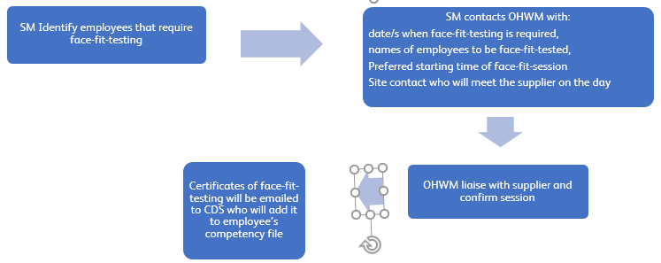
New employees:
Each SM will need to book any new starters that will potentially be issued with tight fitting facemasks as part of their normal PPE to undertake certain work activities linked to their job role.

